|  |  |  |  |  |  |
| --- | --- | --- | --- | --- | --- |
| Date | 30-Nov-22 | | | Tester Name | Janette Paus |
| Environment | Penfax - Test 2 | | | Login used |  |
| Operating System | Windows | Version: 21H2 | Update Number: | | |
| Software Used | Edge | Version: 107.0.1418.56 | Update Number: | | |
| Select Software | Version: | Update Number: | | |
| Application Release version | R22.4.1 | | | | |
| Test Case Title | E 20.1 | | | | |
| Test Type | Regression | | | | |
| Test Scenario | Reverse Termination | | | | |
| Expected Results | The member will be enrolled in the same employment period, and the member status will switch back to active. | | | | |
| Pass/Fail | Pass | | | JIRA# |  |

Do a member search for PEPP & Deferred

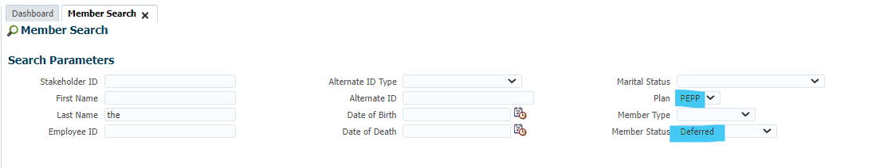

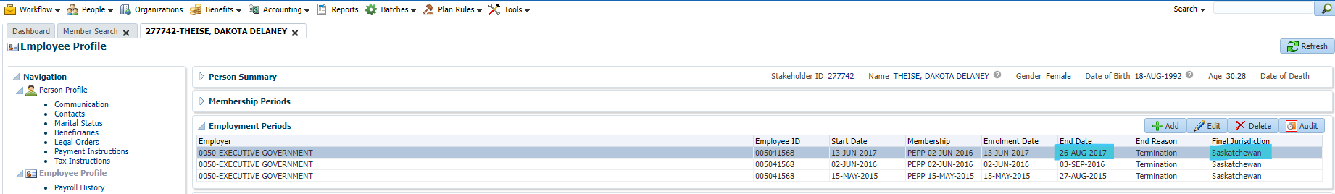

Remove end date &final jurisdiction

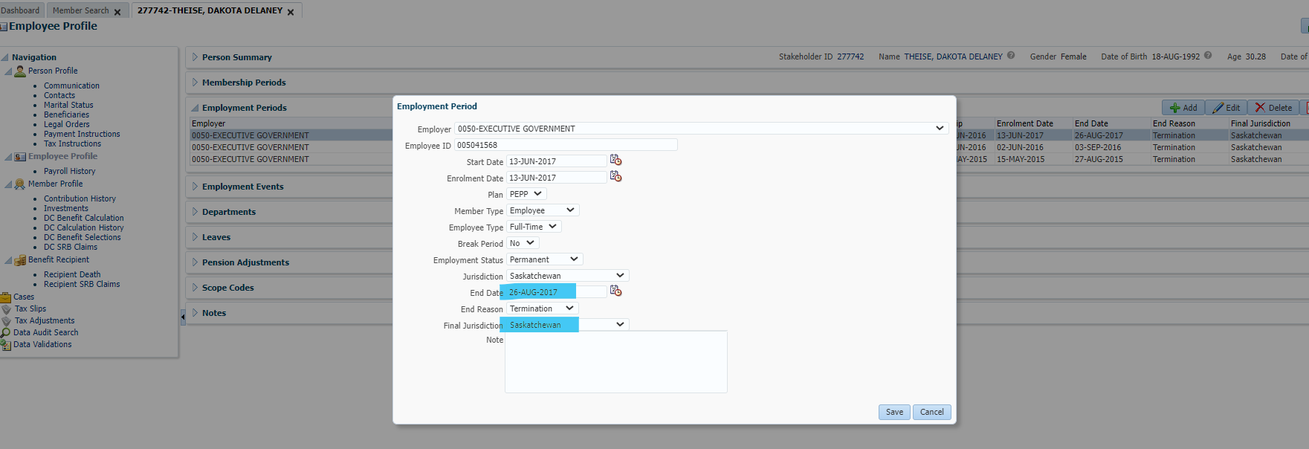

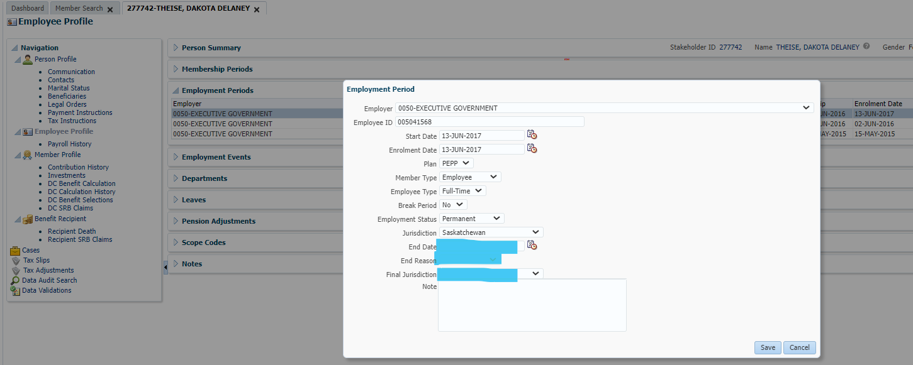

Click Save.

No letter to delete, previously terminated before 2020.

No welcome letter generated – ok.

Had to manually change member status, as it didn’t automatically change – ok. Confirmed with business, this occurs when you reverse any termination prior to PENFAX (otherwise it should update automatically).

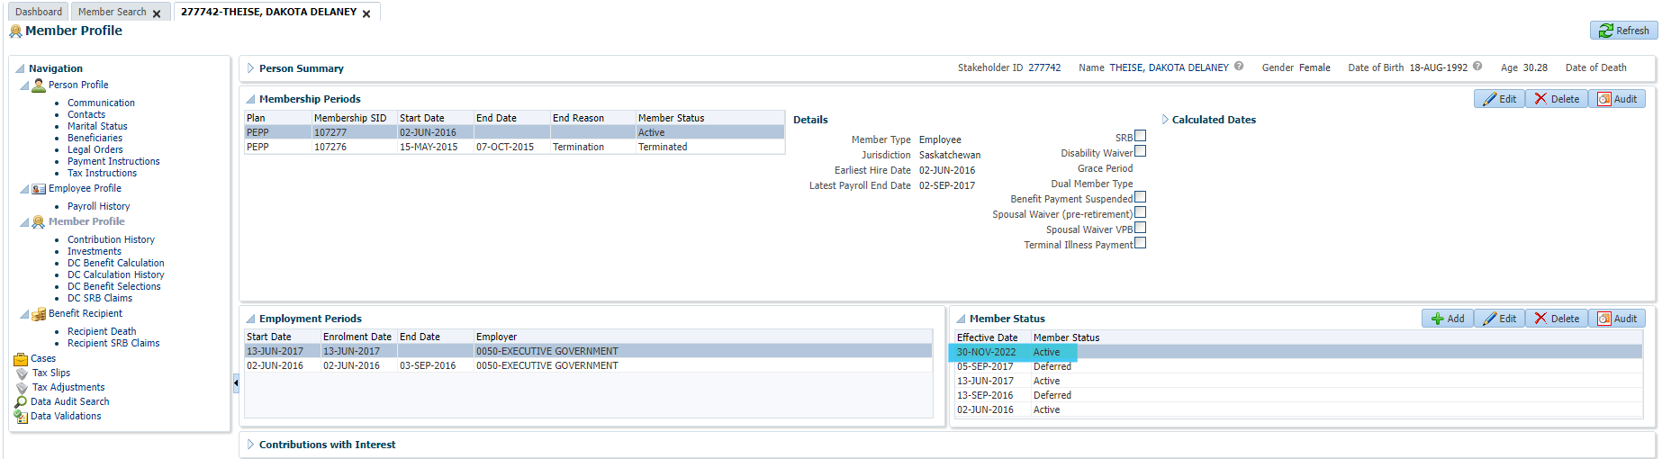

Expected result – membership status is now active. -Passed.